Black Lives Matter

What is it about?
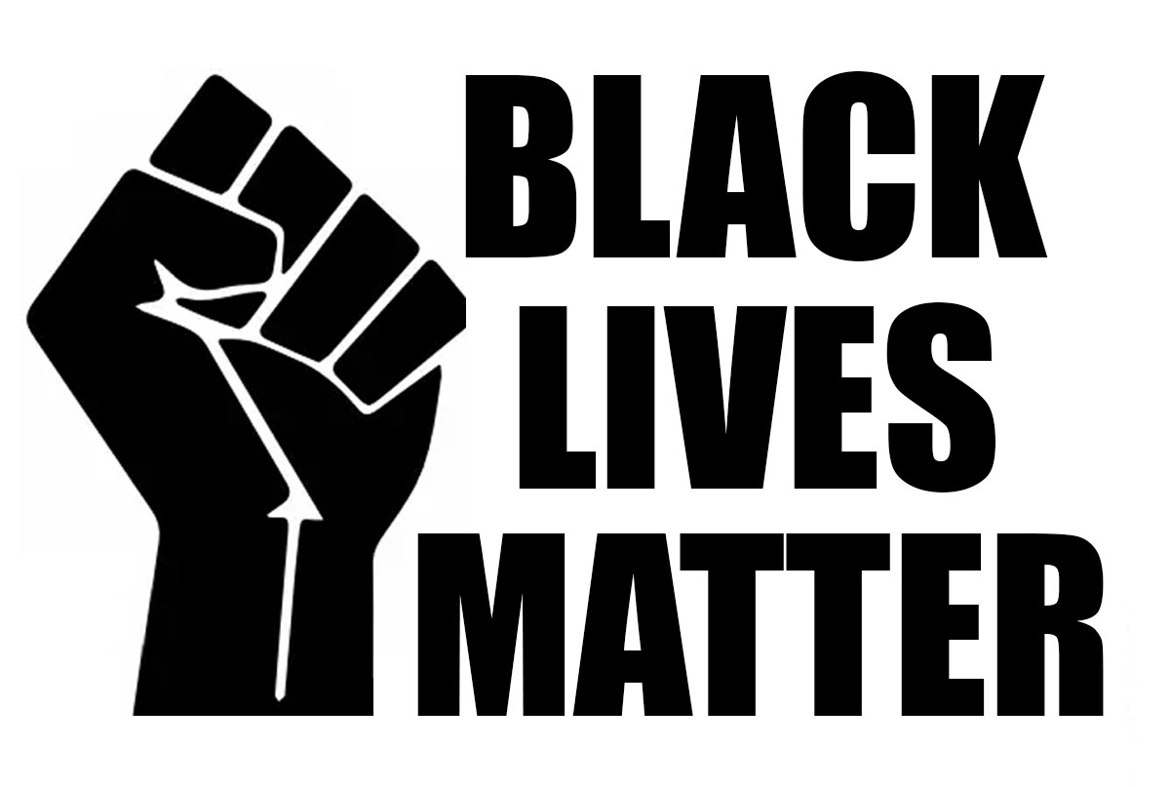
Black Lives Matter is an international human rights movement, which was started in 2013. Today it is a global organisation that is active across the globe. They campaign against violence and racism towards black people. The principles are to eliminate white supremacy as well as violence towards Black communities. According to a study more people of colour died at the hands of police than white people.

White Privilege
White Privilege means to be part of the right group of people. Therefore, they have it much easier in most situations than people of colour any kind. Unfortunately, this still is a huge problem, even in the year 2022. Even today, it is still more difficult for people of colour to pursue their dreams and aspirations. The Black Lives Matter movement tries to change this through fundraising, advocacy and education.

George Floyd
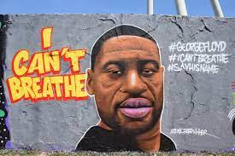
On May 25, 2020, George Floyd, 46-year-old African American, was killed by a white police officer in Minneapolis, while the police officer knelt on his neck for almost 9 minutes. During the whole time George Floyd was handcuffed and lying face down on the street. He continued screaming: “I can’t breathe!”. All over the world, the news reported about this incident. It sparked protests against racism all over the planet.

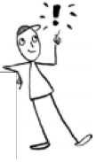

Black Codes and Jim Crow Laws

Many people thought the end of the Civil War would improve the lives of enslaved people in the South. President Abraham Lincoln gave African Americans freedom from slavery and made them citizens of the United States. After they regained citizenship, black people had certain rights by the Constitution. They hoped for a better life. Unfortunately, this wasn’t the case.

Black Codes
In the South, several laws were created, so-called Black Codes (1865). These were rules that were similar to the status of slavery. These codes were ended by the Civil Rights Act of 1867.

Jim Crow Laws
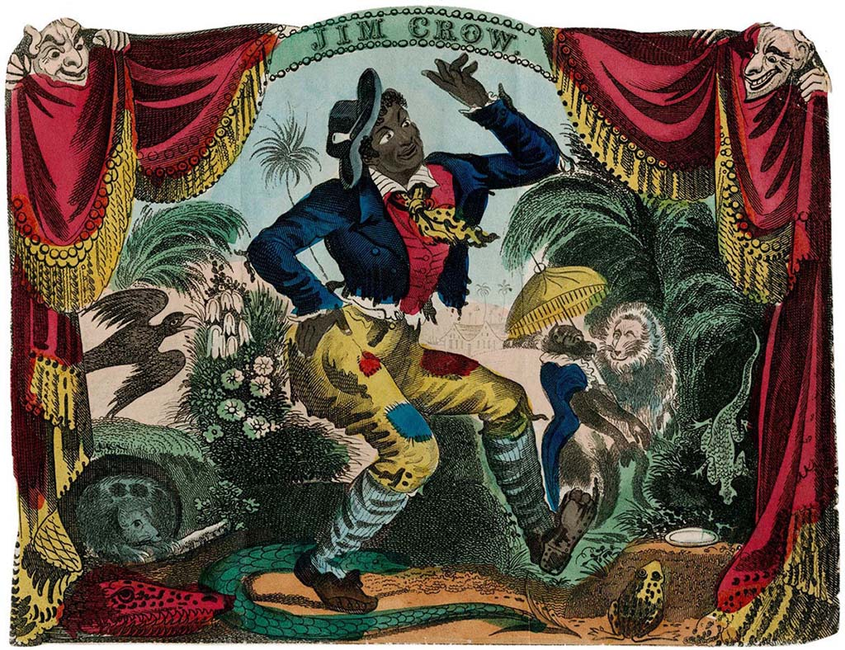
In the following years, the South re-established many of the black codes in the form of the so-called Jim Crow laws (1868). They created segregation between white and African American citizens in public, such as in restaurants, on toilets, in schools and for transportation.
The name “Jim Crow” comes from an African American character from a song in 1832. He was a clown character often played by a white actor who blackened his face and performed like a fool. After the song came out people often referred to African Americans by calling them “Jim Crow”.

Jim Crow Laws – Examples
These laws were created to keep people separated based on their skin colour:
- Waiting rooms had to be separated
- Schools had to have separated classrooms
- Graveyards had separated burial areas
- Until 1948 the US Army was still segregated into skin solour

These laws remained in place for almost a century, but were finally abolished with the passage of the Civil Rights Act of 1964.

Rosa Parks

Early life
Rosa Parks was born in Tuskegee, Alabama on 4th February 1913. She was a Civil Rights activist and therefore very important for the African-American Movement. Her full name was Rosa Louise McCauley. Her mother was a teacher and her father was a carpenter. She had a younger brother named Sylvester. Her parents separated when she was young. Her mother, Sylvester and Rosa moved to her grandparents’ farm. Her mother became very ill, so Rosa had to leave school early to take care of her. When she married Raymond Parks, a successful barber from Montgomery, she worked part-time and went back to school to finish her high school diploma.

Segregation
During this time, things were different for white and black people. They had different schools, different churches, different stores, different lifts, different drinking fountains and separate seats in the bus. Places often had signs saying “For Coloreds Only” or “For Whites Only”.

Montgomery Bus Boycott
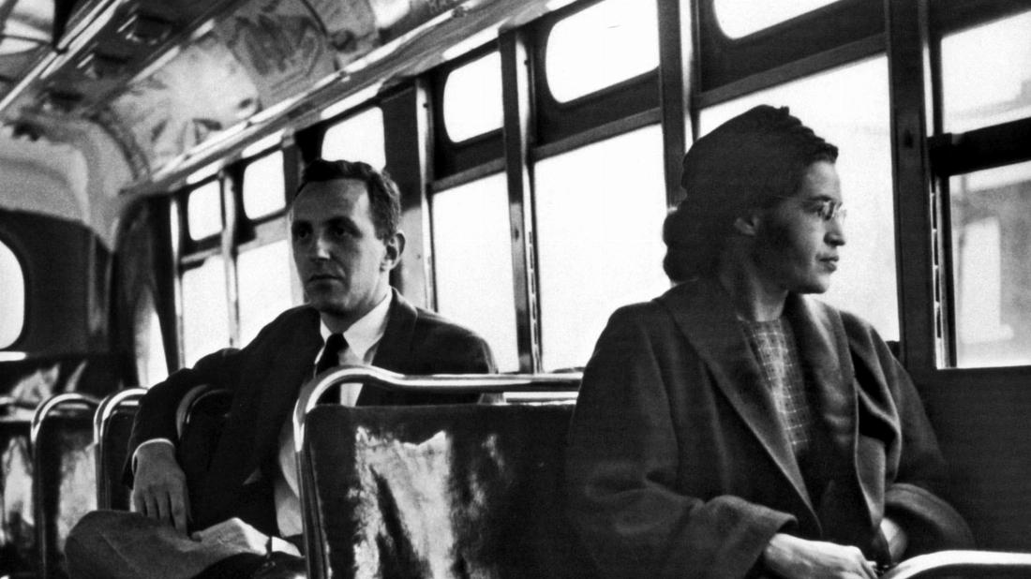
Rosa is most famous for an event that took place in December 1955: She was sitting in a bus and refused to give up her seat, when a white man entered the bus and had no place to sit. Therefore, she was taken to jail. Her arrest and trial caused the Montgomery Bus Boycott, one of the largest and most successful mass movements against racial segregation in history. Martin Luther King organized this boycott and launched the Civil Rights Movement.

Civil Rights Movement
From that day on Rosa attended Civil Rights meetings and to many Afro-Americans she became a symbol of the fight for equal rights and against segregation. However, life didn’t get easier for Rosa and her husband. She received many death threats and so they moved to Detroit in 1957. She died in 2005 at the age of 92 years.

Martin Luther King

Early life
Martin Luther King, Jr., was born in Atlanta, Georgia on 15th January 1929. His real name was Michael Luther King, but he later changed it to Martin Luther King after his father, who was a reverend. In high school his scores were so high that he was accepted to a college without a formal graduation from high school. He skipped the grades 9 and 12, so he was only 15 years old when he started to study theology at Boston University. He received a PhD (Doctor of Philosophy) degree in 1955. Dr. Martin Luther King married Coretta Scott in 1953 and they had four children.

Career
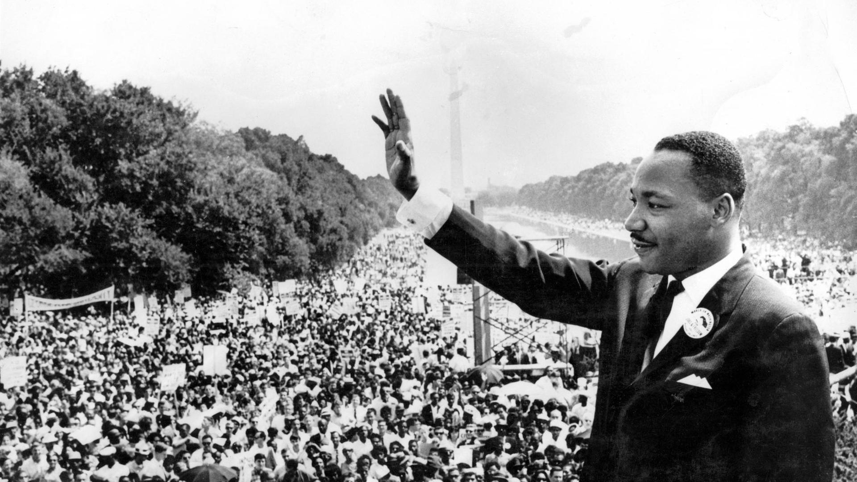
He was, and still is, famous being the driving force in the Civil Rights Movement. His first major civil rights action was the Montgomery Bus Boycott, after Rosa Parks got arrested for not giving up her seat for a white man. In 1963, Dr. King and his supporters organised the famous March on Washington. Over 250000 people attended this march to show sympathy and the importance of civil rights legislation. During this march he performed his famous speech that has written history. He said that he had a dream that his four children would one day live in a nation where they “would not be judged by the colour of their skin, but by the content of their character”.

Awards
He received several awards for his leadership in the Civil Rights Movement and wrote six books as well as numerous articles. Dr. King won the Nobel Peace Prize in 1964 at the age of 35. He was the youngest man, second American and third Afro-American to be awarded the Nobel Peace Prize. It is widely held that his great work changed society for the better and to many people, he is still an inspiration for believing in a world of peace and freedom.

Death
He was killed in April 1968. His death was followed by many riots in cities all over the United States.

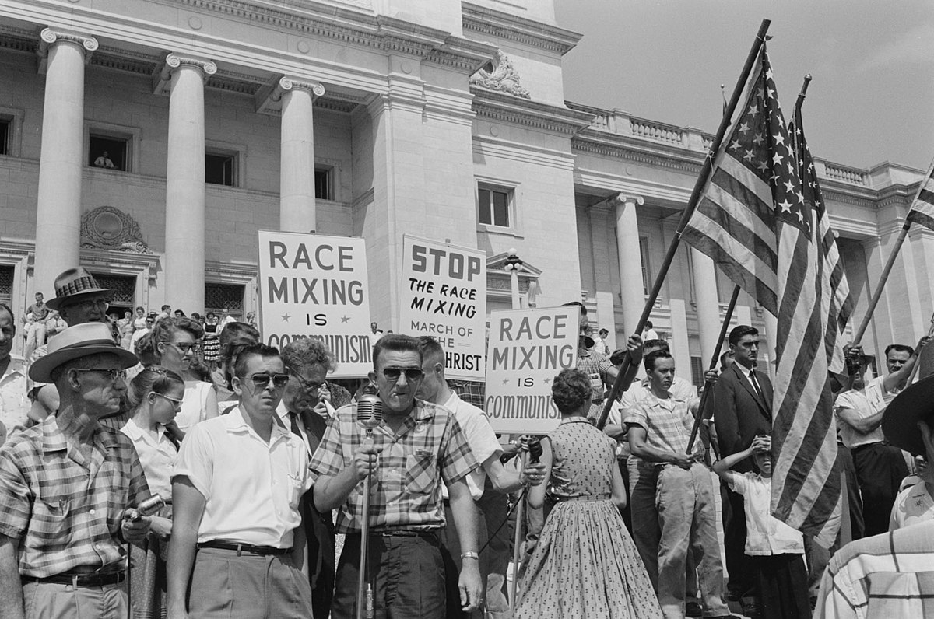
Segregation in school

Little Rock Nine 1957
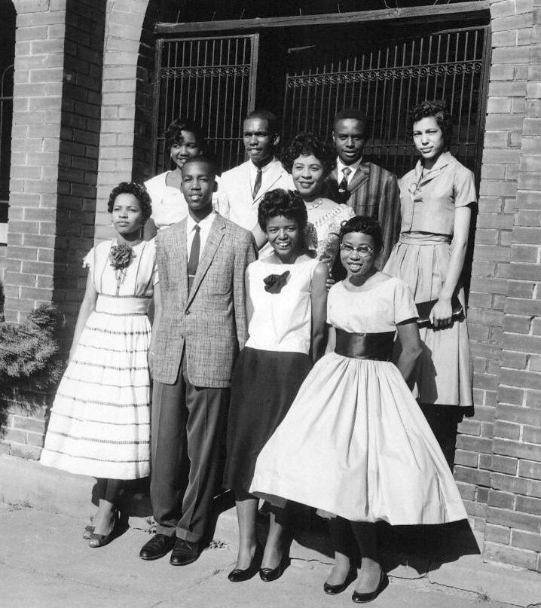
The Supreme Court decision that all schools are equal and segregation in school was illegal, did not lead to a change. Many schools did not want black students at school. In Little Rock, a town in Arkansas, nine African-American students wanted to attend school but they were not allowed. When they went to school, many people protested and the governor had also called the National Guard to stop them from entering school. Later, president Eisenhower sent out the US Army to guard the nine kids to school. It was a tough journey for the nine students but also a great step forward.

Ruby Bridges
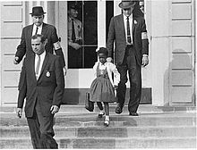
Ruby was the first African-American student who attended an all-white school in New Orleans. She was chosen to go to the all-white school and many white parents protested against her school visit. That is why in 1960 she was guarded to school by four police officers. When they arrived the school was completely empty because all parents had left their kids at home. Day by day, Ruby went to school and faced the hate. In her second year she was no longer escorted by the police and more black kids attended the school.

