Welcome to the Golden State!


Task:
What do you already know about California? Create a mind map.







Task for today:
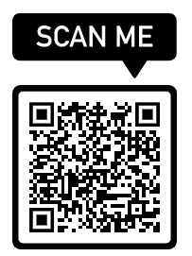
Today we want to travel to California and explore one of the most popular States in the USA! Are you ready?
Please scan the QR code and start the virtual journey with Google Earth! Throughout the tour you have to answer some questions and add important information in your mind map. You are welcome to work in pairs. Be ready to present your mind map at the end of the lesson

